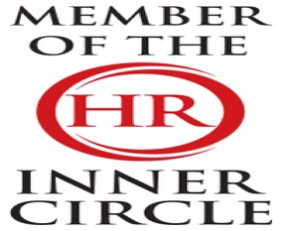 | LBJ Consultants  April 2026 Newsletter |  |  |  |  |  |  |  | 
Contact LBJ Consultants  Our Team  -------------------------  Billy Muir 07375 097443  e mail billy@lbjconsultants.co.uk  -------------------------  Nicola McCulloch 07375 097442  e mail nicola@lbjconsultants.co.uk  -------------------------  Office 07984 568523  e mail enquiries@lbjconsultants.co.uk  Our monthly service contracts are  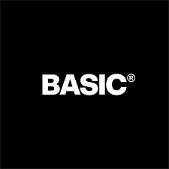  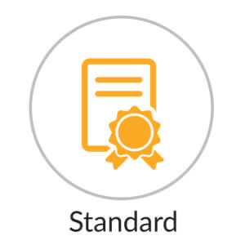    On a rolling   |  |  | How should your business deal with discipline and grievance issues.  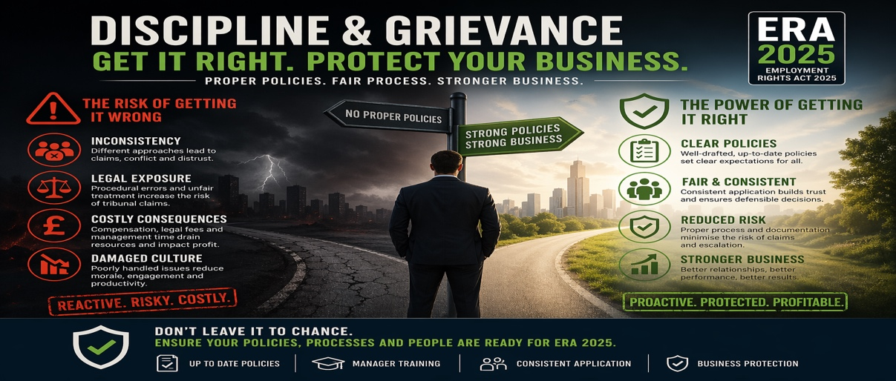  Most SMEs believe they have this covered. They have a policy in place, perhaps a template from years ago, and they assume that’s enough. But that assumption is fundamentally flawed. Having a policy is only the visible part of the protection — the smallest, most passive part. The real risk sits in how those policies are applied in practice, and for most businesses, that risk is far greater than they realise.  When an issue arises, the business doesn’t pause. Decisions are made in real time, often by managers who are under pressure and not fully equipped to handle complex situations. It means inconsistent approaches, missed steps, and procedural errors. It means grievances escalating rather than resolving, and disciplinary matters becoming drawn-out and costly. None of that is reflected in having a policy document — but all of it exposes your business to significant risk.  Now layer in what’s changing in April 2026. SSP will be paid from day one. It will apply to all employees. That means absence becomes more accessible and more frequent, while also becoming more expensive from the very first day. If your current approach is to monitor SSP and assume that’s under control, you are not prepared for what’s coming.  The risk here is not theoretical. It is immediate and measurable.  If you are not actively ensuring your discipline and grievance processes are clear, consistent, and correctly applied today, you are already exposed. And as expectations increase under ERA 2025, that exposure will only grow.  The risk here is not theoretical. It is immediate and measurable.  So, the question is not whether your business has policies in place. It is whether they are robust, understood, and actually protecting you when it matters most.  Strong policies must be supported by confident, capable managers. Without proper training, even the best-written procedures will fail in practice. Managers need to understand not just what the policy says, but how to apply it fairly, consistently, and in line with current legislation. This is where many businesses fall short — and where the greatest risk often sits.  Consistency is critical. Handling similar situations differently across teams or individuals not only damages trust internally, it significantly increases the likelihood of claims. A structured, well-communicated approach ensures that decisions are defensible, documented, and aligned with best practice, reducing both legal and operational risk.  Ultimately, discipline and grievance processes are not just about compliance — they are about control. Businesses that take a proactive, structured approach are better positioned to protect productivity, maintain employee relations, and avoid unnecessary cost. Those that do not will find themselves reacting to issues rather than managing them, often when it is already too late.
We also offer other services on a



Call us on 07984 568523/01292 892713 to dicuss these services
LBJ Consultants  Employee Protection Scheme.  Covers all employment tribunal, settlement and legal costs up to £50,000 for a monthly subscription. |  |  |  | LBJ Consultants  Employee Surveys.  We can offer our clients employee surveys that will identify all issues that employees may have |  |  | LBJ Consultants  HR Management System.  Our HR management System will allow you to record and manage holidays, sick leave, performance management, documentation, pay and allow you to message employees.
The charges are based on the number of employees. Can be as little as £2.00 per month per employee |  |  |  | Call us on 07984 568523/01292 892713 to discuss these services. |  |  | E-mail us on enquiries@lbjconsultants.co.uk to discuss these services.
 |  |  |  |  | Page 1

People for Business | Updates |  |  |  |  | Business for People
Zero-Hours and Low-Hours Contracts: Workforce Risk, Cost & Compliance
Zero-hours and low-hours contracts are under increasing legal scrutiny. Guaranteed hours and shift notice rights will change how flexibility works. Many businesses underestimate their exposure to cost and compliance risk. Workforce data—not assumptions—must drive decisions. Early analysis allows control; late reaction creates cost  Flexible contracts have long supported operational demand across hospitality, retail, and care. The direction of travel is clear—greater predictability, fairness, and worker protection. This is already influencing expectations from regulators, tribunals, and employees. We regularly see businesses assume their current model will continue to work In reality, where working patterns are consistent, obligations are already shifting. |  | In one case, a business discovered that over 60% of its zero-hours workforce were working consistent patterns—exposing them to significant contractual and compliance risk.  From working with SMEs, a consistent pattern emerges with limited visibility of contract types and a disconnect between contracted and actual hours. Scheduling that wouldn’t meet future requirements and financial exposure is not understood.  We also see businesses where managers believe flexibility exists—until data shows the same individuals working near-identical shifts every week. At that point, what appears flexible becomes predictable—and predictable becomes risk. `The issue is not the contract—it is how it operates in practice. Where consistent patterns exist, they may form the basis of future rights. |  |  | We analyse real workforce data and provide practical, commercially focused insight. We focus on what is actually happening—not just what contracts say. Early action allows control. Waiting increases cost and risk. The businesses that act early will protect margins and retain flexibility.  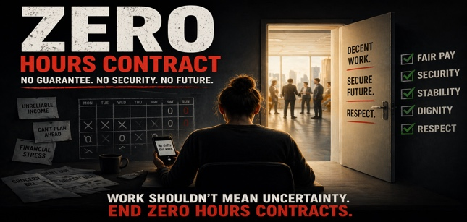
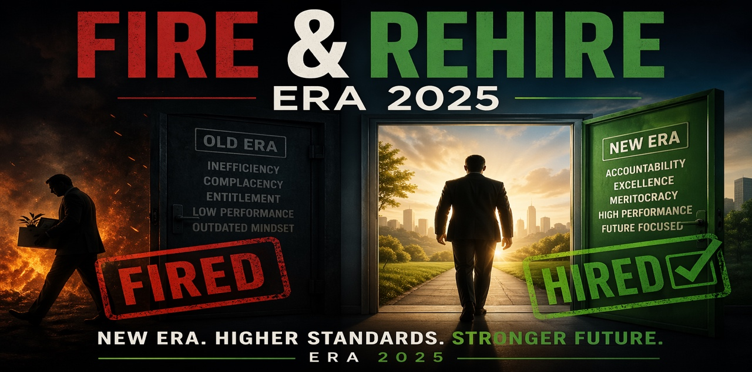 |  |  |  |  | Why Fire and Rehire Is No Longer Appropriate  Historically, businesses used fire and rehire to:  - Change pay structures  - Adjust shift patterns  - Modify contractual benefits  Today, the risk profile is completely different. Employers must now demonstrate fair, reasonable, and consultative approaches—or face significant consequences.  The Risks of Getting It Wrong  Using fire and rehire incorrectly can result in:  - Automatic unfair dismissal claims  - Significant compensation awards  - Damage to employee trust and morale  - Long-term reputational harm  This is no longer a manageable risk it is a high impact exposure.  What a Lawful Approach Looks Like  From what we see working with businesses, a compliant and effective approach includes structured consultation  - Early engagement with employees  - Clear explanation of business rationale  - Genuine opportunity for feedback  - Genuine Negotiation  - Exploring alternatives  - Addressing concerns properly  - Finding workable solutions  - Incentivised Agreement  - Encouraging voluntary agreement  - Structuring proposals fairly  - Reducing resistance and conflict  - Clear and Consistent Communication  - Alignment across managers  - Legally compliant language
Fire and Rehire: Why It’s No Longer a Viable Option - What to Do Instead
What This Means for Your Business
- Fire and rehire is now heavily restricted and high-risk
- Most businesses using it face legal, financial, and reputational exposure
- A consultative, structured approach is now expected
- Getting this wrong can lead to tribunal claims and long-term damage
- There is a safer, more effective way to deliver change
Why This Matters Now
The landscape around fire and rehire has changed significantly—and many businesses haven’t fully adjusted. We regularly see organisations assume this is still a viable fallback option. It isn’t.What was once used as a last resort is now one of the highest risk approaches you can take. In practice, using it incorrectly can trigger immediate legal and reputational consequences.
What We See in Practice
From working with SMEs and larger employers, a consistent pattern emerges when change is handled poorly:
- Decisions made too quickly without proper consultation
- Managers unsure how to communicate change
- Inconsistent messaging across the business
- Escalation into formal disputes or grievances
This is where risk builds—and often where costs begin to escalate.
 |  |  | Page 2

Complete HR | People for Business – Business for People |  |  |  |  |  | One Stop for all support
How Should Businesses Prepare for Increasing Union Activity in the Workplace?   |  | Why Union Readiness Matters Now  The employment landscape is shifting—and many businesses haven’t caught up yet. We regularly see organisations assume this won’t affect them—until it does. In reality, union activity often starts subtly and then builds quickly once momentum develops among employees. At that point, hesitation, inconsistent messaging, or incorrect responses can significantly increase risk.  What We See in Practice  From working with SMEs, there’s a consistent pattern when businesses aren’t prepared.  - Leaders unsure how to respond in real time  - Different managers giving different answers to the same questions  - Delays in escalation while decisions are made internally  - Lack of clarity around legal boundaries and acceptable communication  What Our Union Readiness Workshop Actually Does  This is practical preparation for real situations—not generic training or theoretical advice. |  |  |  | We focus on ensuring your leadership team can act confidently in the moments that matter most. We help leaders:  - Understand union access rights in real-world terms  - Respond confidently to recognition requests  - Communicate clearly without creating legal or reputational risk  Why This Matters Commercially  Union-related issues are not just compliance risks—they are commercial risks. They directly affect:  - Leadership confidence and decision-making  - Employee trust and engagement levels  - Operational stability across teams and sites  - Overall business reputation  Handled well = controlled outcome and reduced risk.  Handled poorly = escalation, disruption, and cost.
What This Means for Your Business
Union access and recognition activity is increasing—and accelerating across multiple sectors. Many SMEs underestimate how quickly situations can escalate from informal conversations to formal processes. Poor handling creates legal, operational, and reputational risk. Consistent, confident leadership response is critical to maintaining control. Preparing early is the most effective way to protect your business
LBJ Consultants Launches New Webinar Training Service  As businesses prepare for increasing employment law changes and operational pressures, the need for accessible, practical HR training has never been greater. At LBJ Consultants, we are responding to that need with the launch of our new webinar-based training service — designed specifically for SMEs who want clarity, confidence, and control in managing their people.  Many organisations recognise the importance of training but struggle to commit the time or resource to traditional, in-person sessions. Webinars remove that barrier. They provide a flexible, cost-effective way to equip managers and business owners with the knowledge they need, without disrupting day-to-day operations.  Our webinar programme focuses on the issues that matter most right now. From discipline and grievance handling to absence management, performance, and preparing for the Employment Rights Act 2025, each session is built to deliver practical, actionable insight — not theory. The aim is simple: to ensure your business is not just compliant, but confident in how it operates.  What sets LBJ Consultants apart is our real-world approach. We don’t just explain legislation — we show you how it applies in practice. Our sessions are designed to help managers make better decisions, avoid common pitfalls, and handle situations consistently and effectively. This is about reducing risk, protecting your business, and improving outcomes across your workforce.  The introduction of webinar training also allows us to support more businesses in a scalable and ongoing way. Rather than one-off sessions, organisations can engage regularly, keeping knowledge up to date as legislation evolves and challenges change. This continuous approach ensures that policies are not just in place, but actively supported by capable, informed managers.  As expectations on employers continue to rise, particularly with upcoming legislative changes, investing in the right training is no longer optional — it is essential. Businesses that prioritise development will be better positioned to manage risk, maintain productivity, and build stronger, more resilient teams.  Our new webinar service is now live, with a schedule of upcoming sessions available. If you want to ensure your business is prepared, protected, and operating with confidence, now is the time to engage. |  |  |  | All webinars will be delivered via Microsoft Teams, making access simple and familiar for most organisations. Attendees can join live sessions from anywhere, allowing for real-time engagement, discussion, and the opportunity to ask questions directly to our experts. This ensures the training remains interactive and relevant to the challenges your business is facing.  For those unable to attend live, every session will also be recorded and made available on demand. This provides complete flexibility, enabling businesses to access training at a time that suits them and to revisit key topics whenever needed. It also allows organisations to extend the value of each session by sharing content across teams.  This dual approach — live and on demand — ensures that learning is not restricted by time or availability. Whether you prefer to engage in the moment or access content at your convenience, our webinar service is designed to fit around your business, not disrupt it.  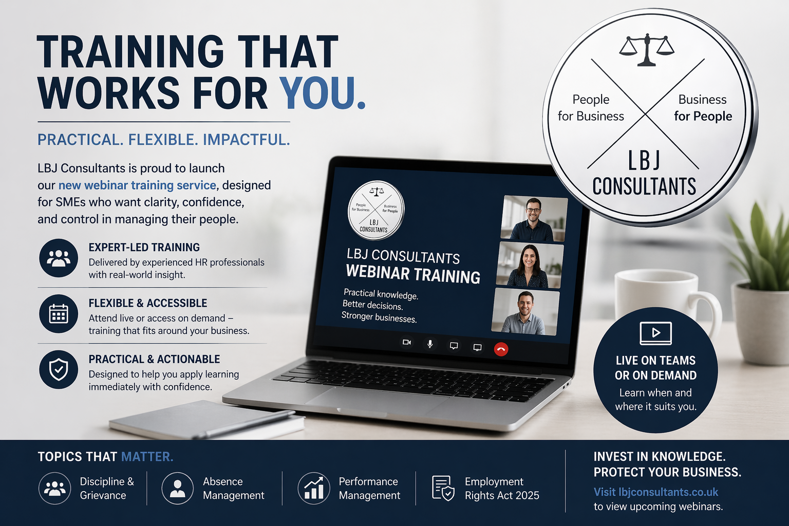
 |  |  | Page 3

People for Business | Awards 2026 |  |  |  |  | Business for People
This overview highlights the key employment law changes taking effect from April 2026 and beyond, covering increases to compensation limits, statutory payments, and minimum wage rates, alongside important updates to tribunal claims and employer obligations. It also outlines upcoming developments under the Employment Rights Act 2025, including enhanced employee protections, extended time limits for claims, and new enforcement measures. For employers, this serves as a clear reminder that both the financial and operational risks associated with people management are increasing, making it essential to ensure policies, processes, and management capability are aligned, up to date, and ready for what’s ahead.
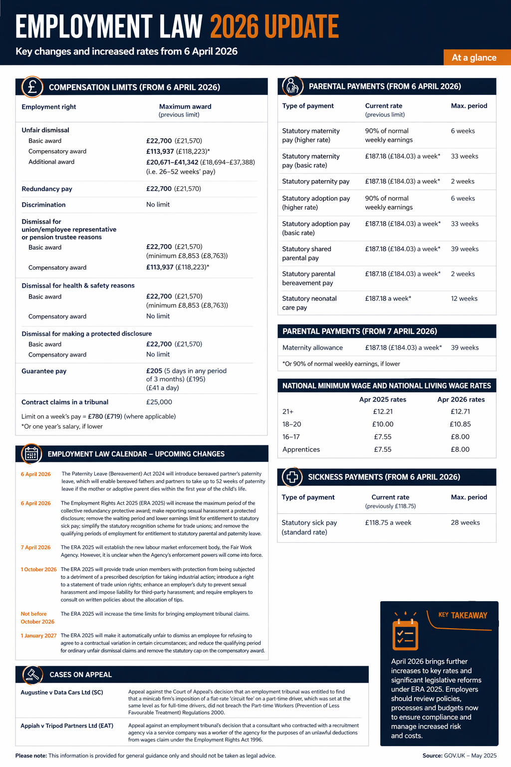

 |  |  | Page 4

