October 24 | LBJ Consultants  Newsletter |  |  |  |  |  |  |  | 31/10/2024
Contact LBJ Consultants  Our Team  enquiries@lbjconsultants.co.uk  -------------------------  Billy Muir 07375 097443  e mail billy@lbjconsultants.co.uk  -------------------------  Terry Stirton 07375 097442  e mail terry@lbjconsultants.co.uk  -------------------------  Ellie Stenton 07984 568523  e mail ellie@lbjconsultants.co.uk  Our monthly service contracts are  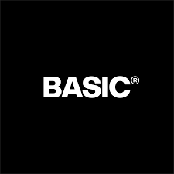      On a rolling  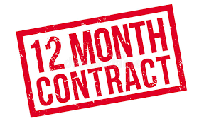 |  |  |  | 
 |  |  |  | We can now provide Legal Protection to go alongside our HR and Employment Law advice. Charges are based on number of employees, from £3.00 per employee per month.
Day one unfair dismissal.
Changes to unfair dismissal rights in its forthcoming Employment Rights Bill?
 |  |  |  | According to information obtained by the Financial Times, the Government is now proposing, under its plans to introduce ‘day one’ unfair dismissal rights in its forthcoming Employment Rights Bill, to allow employers to keep new hires on probation for up to six months.  In and of itself, this development is no surprise. Labour’s pre-election pledge to make unfair dismissal a ‘day one right’ made specific mention of a role for probationary periods. A period of six months is in line with what many contracts of employment already have in place for new hires. What we don’t yet know is exactly how an employer’s ability to stipulate a six-month probationary period will intersect with, and potentially limit, unfair dismissal as a day one right. |  |  |  | Will there be some sort of minimum Acas-type procedure employers will be able to follow for dismissals during probationary periods, which will give them a ‘get out of jail free’ card? Or will there be a statutory defense for dismissals, on certain specified grounds, during the six-month probationary period?  The devil will, as ever, be in the detail – and we don’t have that detail yet. However, we are fast approaching the end of the government’s self-imposed ‘100 day’ deadline to bring forward the draft Employment Rights Bill. These questions and others are likely to be answered soon.
We also offer other services on a

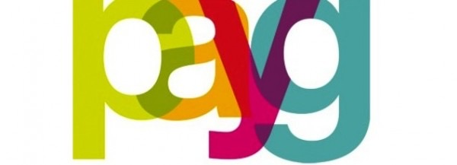
LBJ Consultants  Employee Protection Scheme.  Covers all employment tribunal, settlement and legal costs up to £50,000 for a monthly subscription. |  |  | LBJ Consultants  Employee Surveys.  We can offer our clients employee surveys that will identify all issues that employees may have |  |  |  | LBJ Consultants  HR Management System.  Our HR management System will allow you to record and manage holidays, sick leave, performance management, documentation, pay and allow you to message employees.
The charges are based on the number of employees. Can be as little as £2.00 per month per employee |  |  | Call us on 07375 097443 to discuss these services. |  |  |  | E-mail us on enquiries@lbjconsultants.co.uk to discuss these services.
 |  |  |  |  | Page 1

October 24 | Updates |  |  |  |  |  | 31/10/2024
The legal implications of unclaimed holidays.
Why are employees not using their annual leave?
A recent holiday study by Breathehr has revealed there are several reasons why people aren't using their leave:  - Being worried that taking their annual leave would reflect badly on their performance  - Staff shortages  - A desire to 'reclaim' or sell back their annual leave  - Having more responsibility in their role and being too busy  - Employers not encouraging time off  What are the risks of annual leave not being taken?  When it comes to annual leave, employers should keep in mind that the statutory minimum isn't just a legal box tick - it's also about health and safety. |  |  | It could put employers at risk of violating the Working Time Regulations if employees don’t take their statutory minimum leave within the holiday year.  When employees feel they can't take their annual leave, it also impacts the overall health of the workplace. This often results in a decline in performance and morale. The costs are significant short-term absences alone cost employers an estimated £14 billion each year, while long-term absences add up around £37 billion in lost productivity.  What to do next  Whatever steps an organisation takes to encourage annual leave, it will require proactive management. It’s a crucial part of creating a happy healthy workforce. |  |  | Four ways employers can ensure employees use their annual leave  - Have clear annual leave policies.  - Ensure annual leave is taken.  - Remove the perceived barriers.  - Unlimited leave policies  We can support your company, with our easy-to-use holiday management system.  
 |  |  |  |  |  | Equal pay: market forces not a ‘trump card’  Thandi and ors v Next Retail Employment Tribunal Case  It is the first time that a multiple equal pay claim has succeeded against a national retailer – in this case, the high street store Next – based on a comparison between retail staff based in stores and operatives based in warehouses.  In the Next case, the employment tribunal found that the company could not establish a ‘material factor’ defence under S.69 of the Equality Act 2010 in relation to the difference in basic pay between retail and warehouse staff.  The tribunal had concluded in a previous judgment that sales staff and warehouse operatives carried out work of equal value under S.65(6) EqA, giving rise to a prima facie right to equal pay subject to the defence.  
Call us on 07375 097443 or e-mail enquiries@lbjconsultants.co.uk to discuss.
The benefits of Job evaluation.
Job evaluation, fair pay and pay structures are sensitive topics for employees and employers alike.
These topics are often emotional as they affect people’s lives. How does an employer know that they have the right pay structure in place? Job evaluation is a tool used to determine fair pay and identify any inequities. Human resources are responsible for job evaluation and fair pay for the workforce.  Job evaluation is a system or an activity, conducted by HR teams together with leaders, which aims to determine the value of a role in the business. |  | The method compares jobs and analyses them to ascertain their worth.  Job evaluation is critical to ensure that a coherent approach to pay and pay structure is in place. The challenge some organisations face is that it may be subjective.  Job evaluation is not a straightforward process and requires strong due diligence.
 |  |  |  |  |  | One of the services we offer is carrying out job evaluations and salary reviews for our clients. As you see from the case above Next has lost out with an award that could cost them £30 million.
 |  |  |  | Page 2

October | Updates |  |  |  |  | 31/10/2024
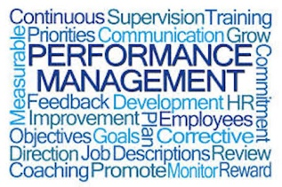 |  | While most economists agree that higher productivity is crucial for improving living standards over time, the impact of remote working on productivity remains uncertain. Speaking in an interview with LBC radio on Monday, at Labour’s annual party conference, Reeves expressed concerns that remote working could make it more difficult to drive efficiency.  ------------------------------------------------------  Government reforms to employment regulations, pay reviews, hiring and investment in future skills are among the key concerns facing UK employers, new research from the Confederation of British Industry (CBI) has found.  The latest annual CBI/Pertemps Employment Trends Survey outlines the challenges facing both Government and business in getting the economy growing again. |  |  | Bosses blind to mental health crisis as absenteeism soars.  Nearly three-quarters (73%) of business leaders believe their organisations are well-prepared to manage mental health concerns in their workforce, according to new research from leading independent consultancy Barnett Waddingham. However, under half of these businesses are collecting comprehensive data on mental health conditions impacting their employees, highlighting significant gaps in understanding the full scope of the issue.  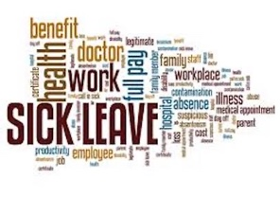
We will support your buiness with all difficult performance management issues.
Chancellor says WFH may hurt productivity - research says otherwise
The Chancellor, Rachel Reeves, says working from home could reduce the chance of boosting economic productivity, despite her party’s plans to introduce new legislation giving workers greater rights around flexible working.

 |  |  |  |  | Our HR management system will help your business manage all absences.
What does the new Employment Rights Bill 2024 cover?
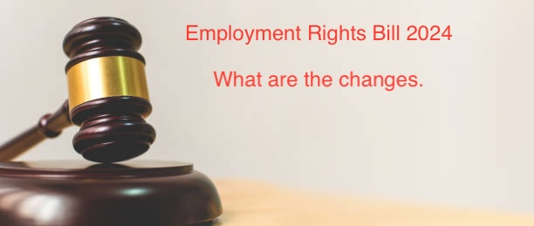
There are numerous legislative changes outlined under the new Employment Rights Bill 2024. Let’s take a closer look at some these areas:
What does the new Employment Rights Bill 2024 cover?
There are numerous legislative changes outlined under the new Employment Rights Bill 2024. Let’s take a closer look at some these areas:
Ban on exploitative zero-hour contracts | Improve sick pay rights for workers
End ‘fire and rehire’ schemes | Establish new Fair Work Agency
Introduce basic workers’ rights from day one | Better pay in adult social care
Improved flexible working arrangements | Better carer’s leave rights
Redundancy protection for new mothers | Update trade union laws
Reinstate School Support Staff Negotiating Body

Are there other laws being passed in connection to the Employment Rights Bill?
- The Equality (Race and Disability) Bill
- The Worker Protection Act
- The Allocation of Tips Act 2023 came into force on 1st October 2024.
Other legislative changes
There are other legislative changes which the government plans to make in relation to the Employment Rights Bill and other relevant laws. These areas include:
- Single worker status.
- Introducing third party harassment.
- Reviewing the family leave framework.
- Extending collective redundancy consultation requirements.
 |  |  | Page 3

October |  | Updates |  |  |  |  |  | 31/10/2024
.
Change is a constant in any workplace, and organisations must stay dynamic to remain competitive and responsive to new challenges. Complacency can stall growth and innovation and it’s important to approach change—whether to processes, values, or attitudes—with thorough planning. Rushing into organisational changes can lead to confusion, resistance, and disruptions in workflow, so thoughtful implementation is key.
There are several key areas that must be addressed when dealing with change and the impact of these changes on employees.
- Planning Is the Key to Success
- Getting Everyone Onboard
- Take It Step by Step
- Involve the Right People
- The Importance of Communication
- Don’t Be Daunted by Change
We have added a full article over this topic on our web page where we cover each point in more details.
You can see this at http;//lbjconsultants.co.uk/
The latest breaking news of the day.
The Worker Protection (Amendment of Equality Act 2010) Act 2023 is enacted on 26th October 24.
 | We now offer a full Health & Safety support service with fully qualified Health & Safety Consultant partner.  Call us on 07375 097443 or e-mail enquiries@lbjconsultants.co.uk for more details. |  |  |  | The importance of whistleblower compensation & protection  Whistleblowers play a critical role in safeguarding organisational integrity by raising concerns about wrongdoing, unethical behaviour, or risks to public safety.  However, those who speak out often face significant personal and professional repercussions. Whistleblowers must be adequately protected in UK workplaces.
The Worker Protection (Amendment of Equality Act 2010) Bill received royal assent on 26 October 2023, creating the Worker Protection (Amendment of Equality Act 2010) Act 2023, which will come into force in October 2024. The Act introduces a new legal duty on employers to take reasonable steps to prevent sexual harassment of their workers (the ‘preventative duty’). Previously there was no proactive legal obligation on employers to take steps to prevent sexual harassment at work. But what will be the implications of this act for employees and employers when the time comes?  The Act also includes the ability for compensation in sexual harassment claims to be increased. If an employment tribunal finds a worker has been sexually harassed, it must consider whether the preventative duty has been met. If not, the employer can be ordered to pay an additional 25% (maximum) compensation.  Sexual harassment is defined as “unwanted conduct of a sexual nature” that has the purpose or effect of “violating a worker’s dignity” or “creating an intimidating, hostile, degrading, humiliating or offensive environment for that worker”.  You can see the full article on our web page at http://lbjconsultants.co.uk/ |  |  |  |  | LBJ Consultants    People for Business - Business for People
The Government has announced the annual national minimum wage increases for 2025. The increases to the minimum wage with effect from 1 April 2025 are as follows:
- and over - will rise from £11.44 to £12.21 an hour
- 18-20 - will rise from £8.60 to £10 an hour
- Apprentices - will rise from £6.40 to £7.55 an hour
This is the largest increase for under 21s on record and is the first step towards a single rate for all adults.
The accommodation offset will rise to £10.66 per day.

 |  |  |  | Page 4

