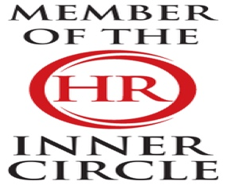 | LBJ Consultants  January 2026 Newsletter |  |  |  |  |  |  |  | 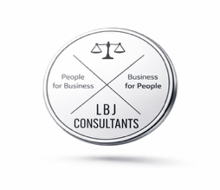
Contact LBJ Consultants  Our Team  -------------------------  Billy Muir 07375 097443  e mail billy@lbjconsultants.co.uk  -------------------------  Nicola McCulloch 07375 097442  e mail nicola@lbjconsultants.co.uk  -------------------------  Troon Office 01292 892713 or  07984 568523  e mail enquiries@lbjconsultants.co.uk  Our monthly service contracts are  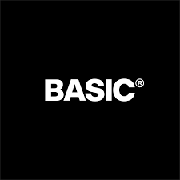  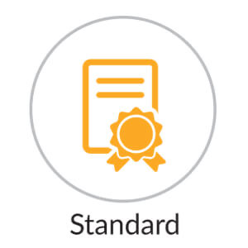    On a rolling   |  |  |  | 
 |  |  |  | Job Evaluation help businesses retain good employees and ensures that they are receiving fair pair.
What is Job Evaluation?
Job evaluations can significantly benefit your business by ensuring roles are clearly defined, fairly graded, and aligned to organisational priorities.
By assessing the purpose, responsibilities, skills, and level of decision-making within each role, job evaluation helps you create a consistent structure across teams.
This supports fair and transparent pay and grading, reducing the risk of pay disputes, equal pay claims, and staff dissatisfaction linked to perceived unfairness.
Job evaluations also improve recruitment and retention. When job descriptions and salary levels reflect the true demands of the role, you attract candidates with the right experience and reduce turnover caused by unrealistic expectations. Internally, job evaluation supports workforce planning by identifying duplication, gaps, and opportunities to redesign roles for better efficiency. It can highlight where work has evolved over time and where responsibilities have increased without formal recognition.
 |  |  |  |  |  |  |  | 
We also offer other services on a

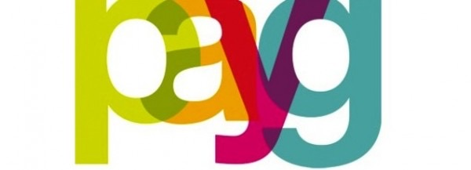

Call us on 07984 568523/01292 892713 to dicuss these services
LBJ Consultants  Employee Protection Scheme.  Covers all employment tribunal, settlement and legal costs up to £50,000 for a monthly subscription. |  |  | LBJ Consultants  Employee Surveys.  We can offer our clients employee surveys that will identify all issues that employees may have |  |  |  | LBJ Consultants  HR Management System.  Our HR management System will allow you to record and manage holidays, sick leave, performance management, documentation, pay and allow you to message employees.
The charges are based on the number of employees. Can be as little as £2.00 per month per employee |  |  | Call us on 07984 568523/01292 892713 to discuss these services. |  |  |  | E-mail us on enquiries@lbjconsultants.co.uk to discuss these services.
 |  |  |  |  | Page 1

People for Business | Updates |  |  |  |  | Business for People
HR Management System does your business need it?
HR Management Systems improve recruitment and retention.
An HR management system (HRMS) benefits a business by improving efficiency, accuracy, and control over people processes.  It centralises employee information in one secure place, making it easier to manage records, contracts, policies, and compliance documentation. This reduces paperwork, saves time, and lowers the risk of lost or outdated information.  An HRMS also streamlines key tasks such as recruitment, onboarding, holiday requests, sickness reporting, timesheets, and performance reviews. Automated workflows and alerts help managers stay on top of probation dates, training needs, and key deadlines, supporting better decision-making and reducing administrative burden. |  | Employees benefit too, as self-service features allow them to update personal details, view payslips, request leave, and access documents quickly, improving transparency and engagement. - Are employees frequently being denied holiday? - This can create burnout and resentment.  Consider implementing clearer policies on when holidays can and should be booked, so everybody is on the same page. Alternatively, you may need to discourage particular managers from refusing holiday requests.  A good system strengthens compliance by keeping audit trails, ensuring documents are stored correctly. It helps businesses meet employment law and data protection requirements. |  |  | It also provides reporting tools that give valuable insights into turnover, absence patterns, staffing costs, and workforce trends—helping leaders plan ahead and control budgets.  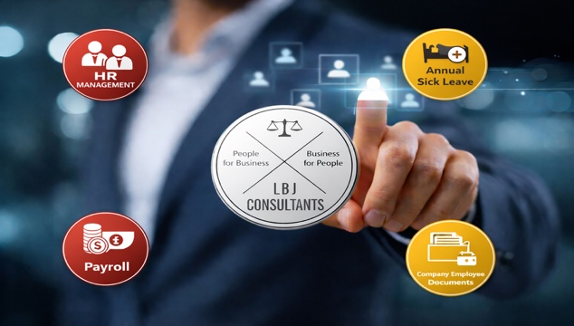
 |  |  |  |  | Overall, an HR management system supports a more organised, consistent, and professional approach to people management
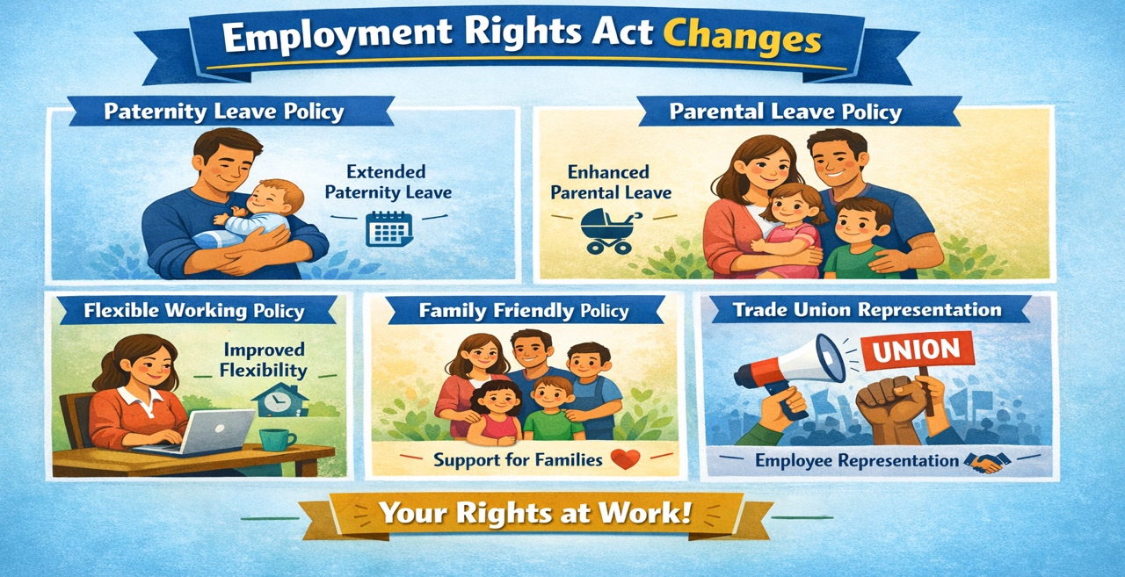 |  |  |  |  | Do you need help with recruitment?  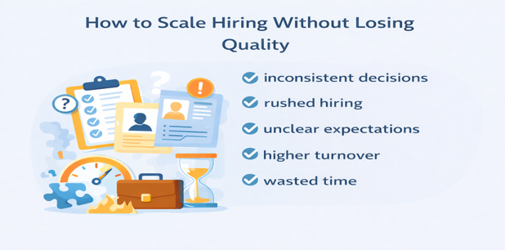  Recruitment must be carried out properly to ensure you appoint the right person for the role, reduce the risk of poor performance or early turnover, and protect service delivery.  A fair, consistent process also helps you demonstrate transparency and equal opportunity, ensuring all candidates are assessed against the same criteria. This supports better decision-making, improves accountability, and strengthens your reputation as an employer. Proper recruitment also reduces legal and operational risk by ensuring that employment checks, references, right to work, and role requirements are confirmed before an offer is made.  Ultimately, getting recruitment right saves time and cost, supports staff wellbeing, and helps the organisation build a stable, skilled workforce that can meet changing needs.
Are your Employment Policies Compliant.
Here’s the problem with many organisations’ HR Policies (maybe yours too)...

- They’re likely to be a ticking tribunal time bomb.
- It’s not a matter of if something will upset the HR applecart to test your policies but when.
- If your HR policies are not robust enough, that could result in a costly and time-consuming tribunal.

Now, if this resonates with you, recognise that it’s not your fault.
It’s not your job to implement effective HR……though as the business owner, it is your responsibility.
So, let us take all that hassle away from you by introducing a solution for you.

In conjunction with the HR Inner Circle, we have updated our HR policy library that now contains over 70 policies that we will amend to suit your business needs..

 |  |  | Page 2

Complete HR | Employment Tribunal Support. |  |  |  |  |  | One Stop for all support
Employment Tribunal Insurance  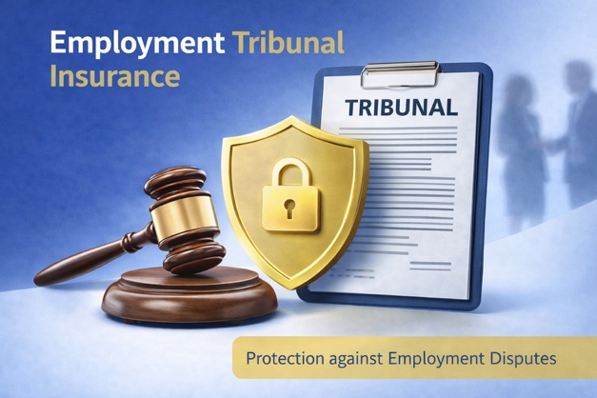 |  | Many businesses choose to settle early—not because they are in the wrong, but because the cost of defending a claim can quickly outweigh the settlement itself.  That’s why we’ve partnered with Albion Insurance to provide a comprehensive Employment Protection Scheme, giving your business the confidence to defend claims properly—without worrying about spiraling costs.  EMPLOYEE INSURANCE PROTECTION  Employment Tribunal & Legal Expenses Insurance  - Cover for employment tribunal claims  - Legal expenses protection  - Claims related to:  - Unfair dismissal  - Discrimination  - Breach of contract  Insurance validity supported by expert HR advice. |  |  |  | Why Employment Tribunal Insurance matters  Without insurance, even a straightforward tribunal claim can result in:  - Significant legal fees  - Pressure to settle early  - Lost management time  - Unplanned tribunal awards  Our Employment Protection Scheme removes that risk by providing structured, reliable cover when you need it most.  What our Employment Protection Scheme covers  Our policy protects your business against:  Employment tribunal costs  Legal fees  Settlement agreements  Tribunal awards  This cover forms a key part of how we help safeguard our clients’ businesses.
Protect your business from costly claims with confidence
Employment tribunal claims are one of the biggest financial and operational risks facing employers today.

What the policy includes in practice
- Dealing with ACAS
- Preparing and responding to ET1 and ET3 documentation
- Legal representation
- Payment of tribunal awards
- Discussing settlement agreements.
Benefits of Training Employees

Offering training through both on-site delivery and e-learning gives businesses a flexible, cost-effective way to develop staff skills and improve performance. On-site training provides direct, face-to-face learning where employees can ask questions, practise tasks, and receive immediate feedback. It is especially useful for hands-on roles, team-based activities, and training that requires demonstration, such as equipment use, health and safety, customer service, or safeguarding.

On-site sessions also strengthen team relationships, improve communication, and create a shared understanding of expected standards across the workforce. Employees often feel more engaged and supported when training is delivered in person, which can boost confidence and morale.Employers, as seen in this case, must ensure that they do not discriminate against employees when they make decisions to dismiss their employees! Proper legal advice must be taken before any disciplinary proceeds.
E-learning adds further benefits by allowing staff to learn at their own pace and revisit materials whenever needed. This is ideal for refresher training, policy updates, and standard compliance modules such as GDPR, equality and diversity, and infection control.  E-learning can also be accessed across multiple locations, supporting remote or hybrid working and ensuring consistency in training delivery. It reduces travel and venue costs, minimises disruption to services, and helps managers track completion through online reporting.  Using both methods together creates a blended learning approach that suits different learning styles and work patterns. Staff can complete core knowledge online and then build practical skills during on-site workshops. This improves knowledge retention and helps employees apply learning more confidently in their roles. |  |  |  | 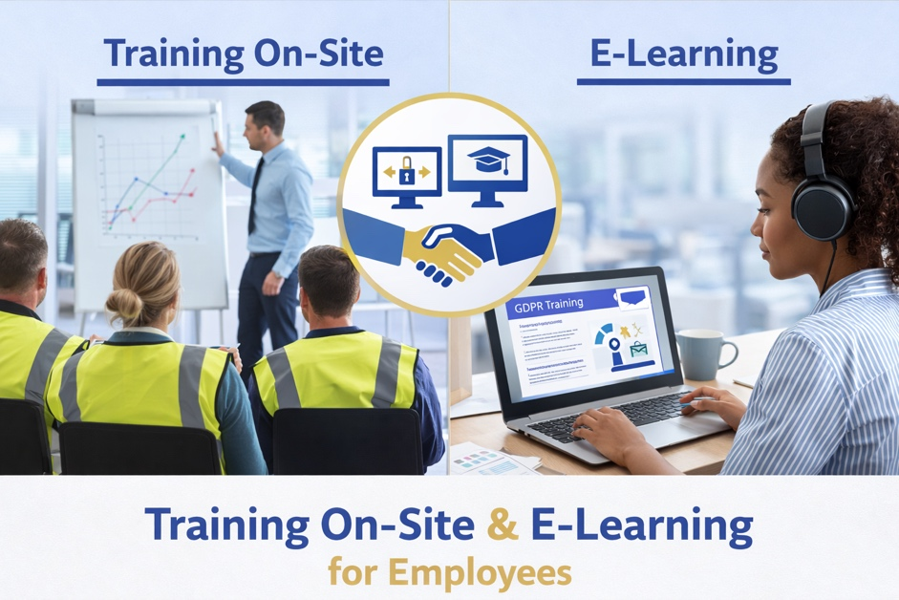  A strong training program, also improves recruitment and retention, as employees are more likely to stay with an organisation that invests in their development. Overall, offering on-site training and e-learning supports a more skilled, motivated workforce, strengthens compliance, increases productivity, and helps the business adapt to change more effectively.
 |  |  | Page 3

People for Business |  | Occupational Health Referral. |  |  |  |  |  | Business for People
When should an Occupational Health referral be made?
An occupational health (OH) review should be arranged when an employee’s health is affecting their ability to work safely, consistently, or effectively, or when there is uncertainty about what support is needed. It is commonly used for long-term sickness absence (for example, several weeks or more) to understand likely timescales for return, any restrictions, and what adjustments could help. It can also be helpful for repeated short-term absences, especially where there is a pattern or an underlying condition may be involved.An employee has bravely confided in you about their health condition, and you aren’t sure what needs to be done. As a line/HR manager it’s unlikely that you’re a medical professional, which means you probably aren’t going to be best place to make decisions on what treatment or support would best help the employee to manage their condition.
This is where an occupational health referral can help. You’ll receive the advice and information you need to support the employee and your organisation.
An OH referral should be considered when an employee reports a medical condition, injury, stress, or mental health concern that impacts performance, attendance, or wellbeing at work. It is also appropriate where a manager is considering capability procedures, ill-health dismissal, or a phased return, and needs professional advice to make fair decisions.
OH reviews are important when the role involves safety-critical duties, lone working, driving, use of machinery, or safeguarding responsibilities, and there are concerns about fitness to work. They may also be needed during pregnancy, after workplace accidents, or where medication could affect alertness.
Overall, an OH review should be done early enough to support recovery and reduce risk, but only with the employee’s knowledge and consent, and with a clear purpose linked to workplace needs.

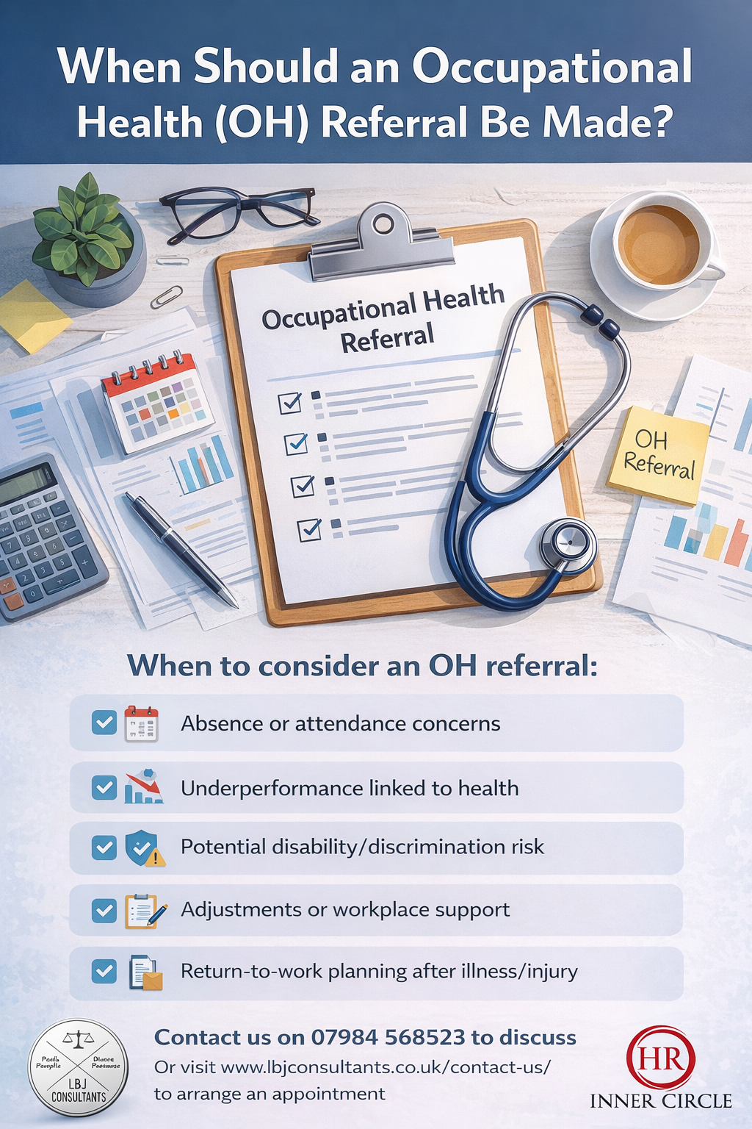

Complete HR Protect One Provider/Total Employment Protection.
We can provide your HR, Employment Law, Health & Safety advice and support that is enhanced by our branded HR Management System that will provide all your Payroll and Pension requirements; all protected by our business tribunal insurance. All our services are guaranteed GDPR compliant.
We provide everything that your business needs to stay compliant, protected and productive.
At LBJ Consultants, we provide clear, professional HR consultancy across Scotland, including outsourced Employment Law & HR support and retained HR services designed around the needs of small and growing businesses.
 | We now offer a full Health & Safety support service with fully qualified Health & Safety Consultant partner.  Call us on 07375 097442 or e-mail enquiries@lbjconsultants.co.uk for more details. |  |  |  |   People for Business - Business for People
 |  |  |  | Page 4

