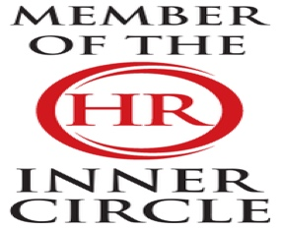 | LBJ Consultants  February 2026 Newsletter |  |  |  |  |  |  |  | 
Contact LBJ Consultants  Our Team  -------------------------  Billy Muir 07375 097443  e mail billy@lbjconsultants.co.uk  -------------------------  Nicola McCulloch 07375 097442  e mail nicola@lbjconsultants.co.uk  -------------------------  Office 07984 568523  e mail enquiries@lbjconsultants.co.uk  Our monthly service contracts are        On a rolling   |  |  | 
 |  |  | In UK law, redundancy can be a fair reason for dismissal — but only if the process is done properly.
How Redundancy Works (And Why It Matters More Than You Think).
Redundancy might sound like a dry technical term, but it’s one of the most important ideas behind keeping organisations stable in uncertain times.
What Is Redundancy?
At its core, redundancy is the process of removing roles where the work is no longer needed, or where the organisation needs to restructure to remain sustainable. In UK employment law, redundancy is a potentially fair reason for dismissal — but only if it is handled properly.
 |  |  | How the Redundancy Process Works  While every situation is different, a legally safer redundancy process usually follows a familiar structure:  1) Identify the Business Reason  2) Define the Redundancy Pool  3) Choose Fair Selection Criteria  4) Consult Properly  5) Consider Alternatives  6) Confirm Outcomes and Provide Appeal  The Cost of Getting Redundancy Wrong |  |  |  |  | A poorly handled redundancy process can result in:  - Individual unfair dismissal claims with compensation reaching £118,223 per person (and soon, potentially, unlimited).  - Discrimination claims with unlimited compensation if your selection criteria inadvertently disadvantage protected groups.  Collective consultation failures that can cost your organisation dearly even if no one loses their job — under the Employment Rights Act it’ll soon be a penalty of six months’ pay per affected employee
We also offer other services on a



Call us on 07984 568523/01292 892713 to dicuss these services
LBJ Consultants  Employee Protection Scheme.  Covers all employment tribunal, settlement and legal costs up to £50,000 for a monthly subscription. |  |  |  | LBJ Consultants  Employee Surveys.  We can offer our clients employee surveys that will identify all issues that employees may have |  |  | LBJ Consultants  HR Management System.  Our HR management System will allow you to record and manage holidays, sick leave, performance management, documentation, pay and allow you to message employees.
The charges are based on the number of employees. Can be as little as £2.00 per month per employee |  |  |  | Call us on 07984 568523/01292 892713 to discuss these services. |  |  | E-mail us on enquiries@lbjconsultants.co.uk to discuss these services.
 |  |  |  |  | Page 1

People for Business | Updates |  |  |  |  | Business for People
Employment Policies?
Here’s the problem with many organisations’ HR Policies (maybe yours too)...
- They’re likely to be a ticking tribunal time bomb.  - It’s not a matter of if something will upset the HR applecart to test your policies but when.  - If your HR policies are not robust enough, that could result in a costly and time-consuming tribunal.  Now, if this resonates with you, recognise that it’s not your fault. It’s not your job to implement effective HR……though as the business owner, it is your responsibility.  So, let us take all that hassle away from you by introducing a solution for you.  - Do you know how much holiday is taken and when? You can’t make any strategic decisions without the right data, so it’s important to start here. |  | In conjunction with the HR Inner Circle, we have updated our HR policy library It consists of 74 HR policies that are:  - Compact and concise, making them easy to implement  - Practical with effective and efficient HR processes born from years of employment law experience  - Easy to read and understand by colleagues at every level of your business  - Comprehensive, covering the full range of tricky employment issues busy HR professionals have to deal  - with every day  - Fully legally compliant as they include every relevant employment legislation change since 2020 |  |  | We will review your existing policies and offer advice where you need to update or renew these policies. We have various packages available to help you become compliant  
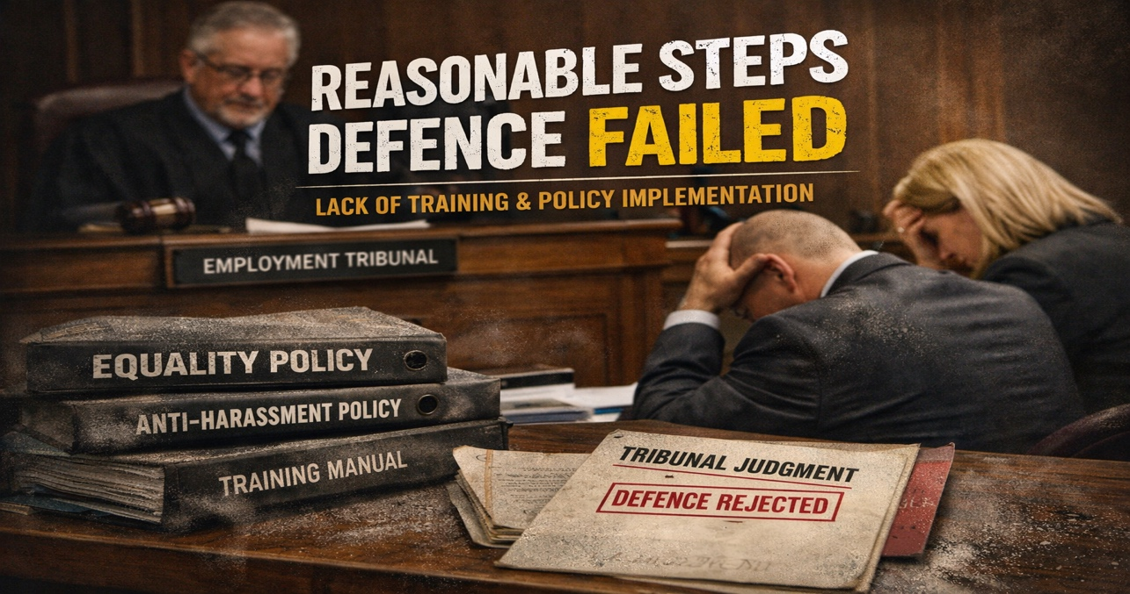 |  |  |  |  | In other words: having a policy document isn’t the same as having a compliant workplace.  Key lessons for employers (and franchise operators)  Discriminatory language will almost inevitably amount to harassment  Terms like “slave” aren’t “banter”, “workplace culture”, or “heat of the moment” language — tribunals will treat them as serious race-related harassment.  Excessive working hours can become discrimination when linked to race    Long hours aren’t automatically unlawful — but when extreme rostering and pressure is connected to (or imposed disproportionately due to) race, it can cross the line into direct discrimination and harassment.  Mishandling complaints worsens liability  This case shows how quickly risk escalates when employees are met with hostility, discouraged from raising issues, or pressured to change their account of events. Poor complaint handling often becomes a separate claim (e.g., victimisation) and will typically worsen compensation exposure.  Policies aren’t enough — implementation and evidence are everything  If you want to rely on “reasonable steps”, you need to show evidence of real-world action such as  - training delivered (and refreshed)  - manager guidance and supervision,  - clear escalation routes
Employment Tribunal awarded £66,000 after KFC franchise employee called a “slave” and forced into extreme hours
The tribunal upheld claims for:
- Direct race discrimination
- Race-related harassment
- Victimisation
- Wrongful dismissal

This case is a stark reminder for employers — and especially franchise operators — that policies alone don’t protect you. What matters is what you actually do in practice, and what you can evidence.
Why this case matters: the “reasonable steps” defence failed completely
One of the most significant aspects of this case was the tribunal’s finding that the employer’s “reasonable steps” defence failed.
In discrimination claims, employers may seek to defend themselves by showing they took reasonable steps to prevent discriminatory behaviour (for example, training, clear reporting pathways, documented action when concerns are raised).
Here, the tribunal found no evidence of meaningful preventative measures — including:
- no credible training record,
- no workplace guidance being implemented,
- no operational steps taken to reduce or prevent discriminatory conduct.
 |  |  | Page 2

Complete HR | People for Business – Business for People |  |  |  |  |  | One Stop for all support
LBJ HR Management System:  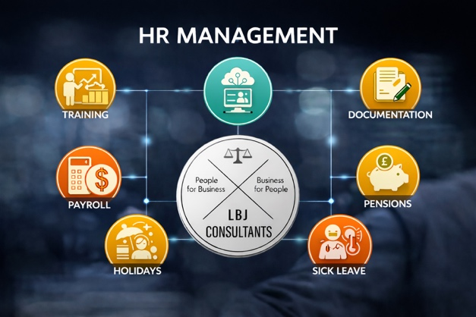 |  | What the LBJ HR Management System covers  - Absence management (record and track)  - Annual leave management (record and track)  - Appraisals & performance management  - Recruitment & onboarding  - Training records  - Health & Safety files  - Payroll (add-on): RTI, pension contributions, and payslips  Who it’s for  The LBJ HR Management System is ideal for organisations that want:  - A single place to record HR essentials properly  - Less admin time and fewer process gaps  - Clearer records for managers, HR, and compliance needs  - Low monthly cost that scales with headcount |  |  |  | Job Evaluation – Salary Reviews.  At LBJ Consultants, we support organisations to build fair, defensible, and sustainable pay frameworks  How We Deliver Job Evaluation- This includes:  - Employee interviews to gain a full understanding of each role  - Completion of Job Analysis Forms to capture responsibilities, tasks, and required skills  - Assessment using established, objective evaluation factors  Salary Review and Grading Structure-This grading structure enables organisations to:  - Manage pay progression in a consistent and cost-controlled way  - Recognise developing capability, full competence, and advanced contribution within the same grade  - Maintain strong internal equity while retaining flexibility to support reward and retention decision  If you are considering a Job Evaluation or Salary Review and want a clear, structured approach that delivers lasting value, LBJ Consultants can help.

One low-cost platform for HR, absence, leave, performance, training, H&S and payroll
If you’re juggling spreadsheets, email trails, and disconnected tools, it’s easy for HR admin to eat up time—and for key records to go missing when you need them most. The LBJ HR Management System brings your people processes into one simple, affordable platform that’s designed for everyday HR work, not complexity.
From absence and annual leave tracking to appraisals, recruitment, onboarding, training records, health & safety files, and payroll—LBJ helps you stay organised, compliant, and in control.
Are Your New Starter Medical Questionnaires Still GDPR Compliant?  Are you currently using new starter medical questionnaires internally? If so, it may be time to take a closer look at your process.  In August 2023, the Information Commissioner’s Office (ICO) released updated guidance to help employers understand their responsibilities when handling employee health information under the UK GDPR and the Data Protection Act 2018. This guidance has important implications for how health data is collected, stored, and assessed — especially during pre-employment checks.  Why Health Data Collection Should Be Kept to a Minimum  The ICO guidance recognises that, while employers may sometimes need health information, collecting medical data is intrusive and should be minimised wherever possible.  Health information is classed as special category data, meaning it requires:  - Higher levels of security  - Clear retention schedules  - Strong justification for collection  For many employers, managing this correctly can be complex and risky.  . 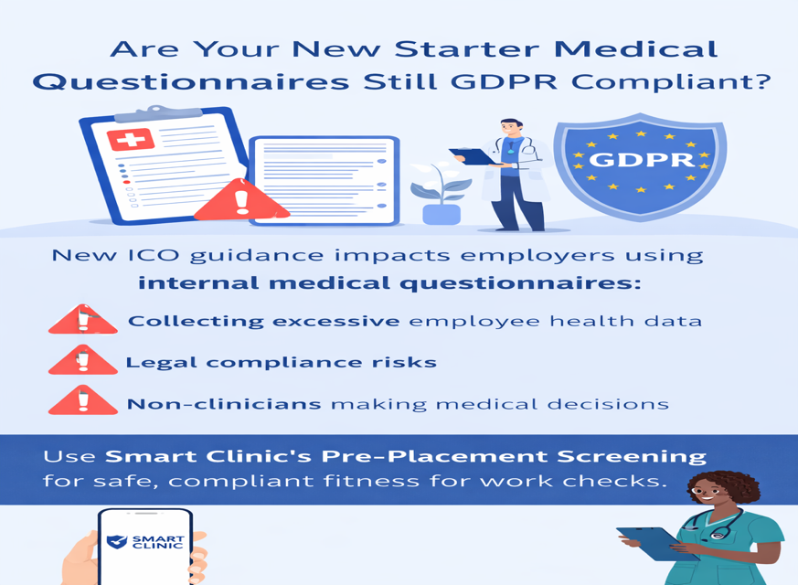 |  |  |  | The Role of Occupational Health Professionals  Rather than employers collecting and interpreting medical information themselves, the ICO advises that medical professionals should gather and assess health data.  Occupational health providers are qualified to:  - Design appropriate health questionnaires  - Interpret clinical information correctly  - Provide non-clinical, practical advice to employers  This approach protects employee privacy and ensures decisions about fitness for work are made responsibly.  The ICO specifically states: “It is good practice for health professionals to design health questionnaires. This also means the questionnaires should be interpreted by those who are qualified to draw meaningful conclusions from the information supplied by the worker.”  New Starter Health Questionnaires Can Be Risky  A Simple, Compliant Alternative  The good news: our service includes access to our Pre-Placement Screening Assessment, designed and reviewed by occupational health professionals.  With us you:  - Remain aligned with ICO and GDPR guidance  - Avoid storing sensitive medical data internally  - Receive clear, fit-for-purpose fitness for work advice  - Remove the burden of clinical decision-making from non-clinicians  Protect Your Business and Your Employees  Time to Scrap the Questionnaires  If you’re still using internal new starter health questionnaires, now is the time to stop.  Scrap the questionnaires and use our Pre-Placement Screening Service for all new starter fitness for work checks — a smarter, safer, and fully compliant solution.
 |  |  | Page 3

People for Business |  | Employment Rights Act 2025 |  |  |  |  |  | Business for People

Key Day-One Rights from April 2026
This document summarises the key employment law changes coming into force in April 2026 under the Employment Rights Act 2025, with practical examples of how they affect pay, contracts, and workplace policies.
1. Statutory Sick Pay (SSP) – Day-One Eligibility
What is changing:
• SSP will be payable from the first day of sickness (removal of waiting days).
• The Lower Earnings Limit is removed, extending SSP eligibility to lower-paid workers.
• SSP will generally be paid at the lower of 80% of average weekly earnings or the statutory SSP rate.
Impact on employers:
• Payroll systems must be updated to calculate SSP from day one.
• HR policies should be amended to reflect expanded SSP eligibility.
2. Paternity Leave – Day-One Right to Take Leave
What is changing:
• Employees will have the right to take statutory paternity leave from the first day of employment.
• The qualifying service period for taking leave is removed.
Important distinction:
• Entitlement to paternity pay may still depend on meeting statutory service and earnings criteria.
• Employers may choose to offer enhanced contractual pay.
Impact on contracts:
• Contracts and handbooks must reflect day-one entitlement to paternity leave.
• Managers should understand the separation between leave entitlement and pay entitlement.
3. Unpaid Parental Leave – Day-One Right
What is changing:
• The qualifying service requirement for unpaid parental leave is removed.
• Employees can request unpaid parental leave from their first day of employment.
Impact on employers:
• Parental leave policies must remove length-of-service conditions.
• Line managers should be trained on notice rules and employee rights.

 | We now offer a full Health & Safety support service with fully qualified Health & Safety Consultant partner.  Call us on 07375 097443 or e-mail enquiries@lbjconsultants.co.uk for more details. |  |  |  | LBJ Consultants  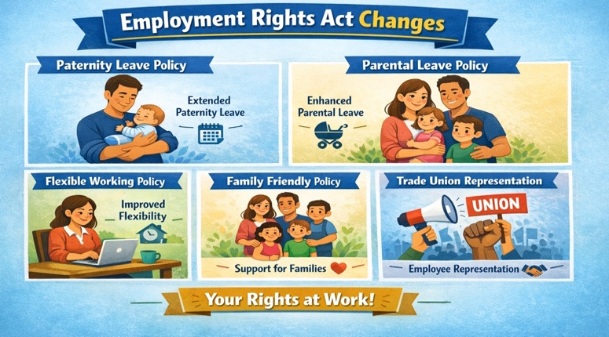  People for Business - Business for People
 |  |  |  | Page 4

