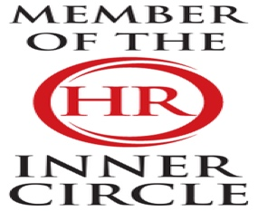 | LBJ Consultants  February 2026 Newsletter |  |  |  |  |  |  |  | 
Contact LBJ Consultants  Our Team  -------------------------  Billy Muir 07375 097443  e mail billy@lbjconsultants.co.uk  -------------------------  Nicola McCulloch 07375 097442  e mail nicola@lbjconsultants.co.uk  -------------------------  Office 07984 568523  e mail enquiries@lbjconsultants.co.uk  Our monthly service contracts are  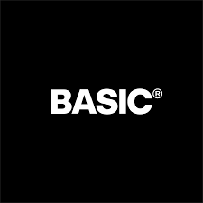      On a rolling   |  |  | 
 |  |  | SSP will now be paid to all employees from day 1. The Lowere Earning Limit has been abolished. This will lead to additional costs for all SMEs.
How should your business deal with staff absences.
Most SMEs believe they understand the cost of staff absence. They look at Statutory Sick Pay, they see a number, and they assume that’s the impact. But that assumption is fundamentally flawed. SSP is only the visible part of the cost — the smallest, most controlled part. The real cost sits elsewhere, and for most businesses, it is significantly higher than they realise.
When someone is off work, the business doesn’t stop. The work still needs to be done. That means someone else is covering it, often at a higher cost. It means managers are reallocating time, shifting priorities, and firefighting operational gaps. It means productivity drops, quality can suffer, and pressure builds across the team. None of that is reflected in SSP — but all of it impacts your bottom line.
Now layer in what’s changing in April 2026. SSP will be paid from day one. It will apply to all employees. That means absence becomes more accessible and more frequent, while also becoming more expensive from the very first day. If your current approach is to monitor SSP and assume that’s under control, you are not prepared for what’s coming.
 |  |  | Now layer in what’s changing in April 2026. SSP will be paid from day one. It will apply to all employees.  That means absence becomes more accessible and more frequent, while also becoming more expensive from the very first day. If your current approach is to monitor SSP and assume that’s under control, you are not prepared for what’s coming.  The risk here is not theoretical. It is immediate and measurable. |  |  |  |  | If you are not actively tracking and managing the full cost of absence today, you are already losing margin. And when costs increase in 2026, that loss will accelerate.  So, the question is not whether absence is costing your business. It is how much — and whether you have any real visibility or control over it.
We also offer other services on a



Call us on 07984 568523/01292 892713 to dicuss these services
LBJ Consultants  Employee Protection Scheme.  Covers all employment tribunal, settlement and legal costs up to £50,000 for a monthly subscription. |  |  |  | LBJ Consultants  Employee Surveys.  We can offer our clients employee surveys that will identify all issues that employees may have |  |  | LBJ Consultants  HR Management System.  Our HR management System will allow you to record and manage holidays, sick leave, performance management, documentation, pay and allow you to message employees.
The charges are based on the number of employees. Can be as little as £2.00 per month per employee |  |  |  | Call us on 07984 568523/01292 892713 to discuss these services. |  |  | E-mail us on enquiries@lbjconsultants.co.uk to discuss these services.
 |  |  |  |  | Page 1

People for Business | Updates |  |  |  |  | Business for People
Preventing and Managing Harassment / Sexual Harassment in the Workplace
At its core, this is about making sure everyone feels safe, respected, and comfortable at work.  In simple terms, harassment is behaviour that makes someone feel uncomfortable, upset, or unsafe—especially if it relates to something personal like their age, race, gender, or beliefs.  The law describes harassment as unwanted behaviour that can cause distress or affect someone’s dignity. It can include things like verbal abuse, threats, inappropriate comments, or unwanted sexual behaviour. But don’t worry about remembering the legal wording—the important thing is understanding how it works in real life.  Because this isn’t just about rules or policies. It’s about how we treat each other every day. |  | Think about a normal working day. You’re talking to colleagues, sending messages, maybe dealing with customers or attending meetings. In all of these situations, your behaviour has an impact on others—even if you don’t realise it.  And here’s the key point: it’s not just about what you meant—it’s about how it was received. You might think something is harmless or just a joke, but someone else might feel uncomfortable, embarrassed, or even upset. That’s where problems can start.  For example, it could be:  - A joke that goes too far  - Comments about someone  - Leaving someone out  - Or speaking to someone in a way that feels disrespectful. |  |  | These things might seem small, but they can have a big impact—especially if they happen more than once. The law also looks at things like:  - How the person felt  - The situation it happened in  - And whether it’s reasonable for it to have that effect  But in simple terms—if it makes someone feel uncomfortable or disrespected, it needs to be taken seriously. Why does this matter? To sum up, harassment is about how people are treated. If we all take responsibility for our behaviour and look out for each other, we create a workplace where people feel safe, valued, and respected.
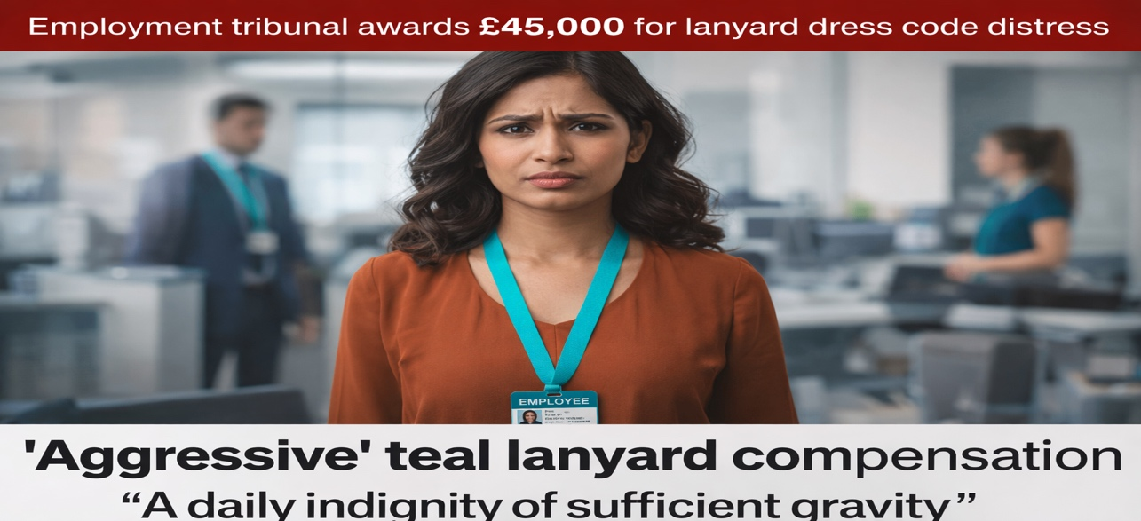 |  |  |  |  | In other words: having a policy document isn’t the same as having a compliant workplace.  Key lessons for employers (and franchise operators)  Discriminatory language will almost inevitably amount to harassment  Terms like “slave” aren’t “banter”, “workplace culture”, or “heat of the moment” language — tribunals will treat them as serious race-related harassment.  Excessive working hours can become discrimination when linked to race    Long hours aren’t automatically unlawful — but when extreme rostering and pressure is connected to (or imposed disproportionately due to) race, it can cross the line into direct discrimination and harassment.  Mishandling complaints worsens liability  This case shows how quickly risk escalates when employees are met with hostility, discouraged from raising issues, or pressured to change their account of events. Poor complaint handling often becomes a separate claim (e.g., victimisation) and will typically worsen compensation exposure.  Policies aren’t enough — implementation and evidence are everything  If you want to rely on “reasonable steps”, you need to show evidence of real-world action such as  - training delivered (and refreshed)  - manager guidance and supervision,  - clear escalation routes
Employment Tribunal awarded £45,000 for injury to feelings over a dress code issue.
An employment tribunal in Leeds has ruled in Fontaine v Helvetica Solutions that a compulsory workplace lanyard policy amounted to a detriment under the Equality Act 2010 after a claimant demonstrated that the lanyard in question - a polyester-blend design in corporate teal - clashed so severely with her complexion and personal aesthetic as to constitute a daily indignity of sufficient gravity to satisfy the detriment threshold.
The tribunal accepted expert evidence from a workplace wellbeing consultant, a colour psychologist and a personal stylist who gave evidence by video link from Milan. The employer’s defence - that the lanyard was required for building security and that “everyone has to wear one” - was rejected on the basis that “everyone suffering equally does not negate individual suffering.”
The tribunal awarded £45,000 for injury to feelings, describing the teal as “aggressive”. The judge added that the lanyard’s font - Helvetica Neue in 8 point - was “an aggravating feature”.
Vento
The annual update to the Vento guidelines (which give ranges for injury to feelings awards in discrimination cases, depending on severity) have been published. In respect of claims presented to the employment tribunal on or after 6 April 2026, the Vento bands (as they are known) are as follows:
- a lower band of £1,300 to £12,600 (less serious cases);
- a middle band of £12,600 to £37,700 (cases that do not merit an award in the upper band); and,
- an upper band of £37,700 to £62,900 (the most serious cases) with the most exceptional cases capable of exceeding £62,900.

 |  |  | Page 2

Complete HR | People for Business – Business for People |  |  |  |  |  | One Stop for all support
LBJ HR Management System:  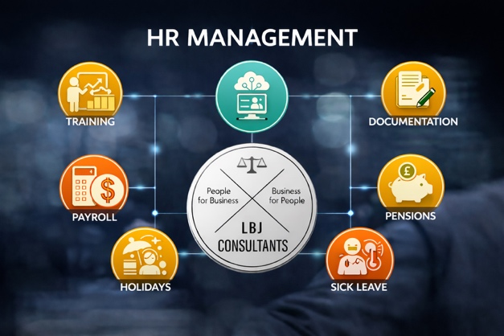 |  | What Records Must Be Kept: Employers must hold "adequate records" that demonstrate compliance with holiday entitlement. This includes the amount of statutory annual leave taken by each worker, the calculation of holiday pay, and payments made for unused leave upon termination.  Retention Period: Records must be kept for six years from the date they are created, even if the worker has left the company.  Enforcement: The new "Fair Work Agency" (FWA) will be responsible for enforcing these rules and has the power to inspect records, enter premises, and issue penalties.  Penalties for Non-Compliance: Failure to keep adequate records can result in criminal prosecution and unlimited fines. Additionally, if records show underpayment of holiday pay, the FWA can impose penalties of 200% of the underpayment, capped at £20,000 per worker.  Definition of Records: The law allows employers to create and maintain records in whatever format they see fit, but the records must be accurate enough to demonstrate compliance.  What Employers Should Do Now:  - Audit Current Systems:  - Update Processes:  - Review Documentation: |  |  |  | Job Evaluation – Salary Reviews.  At LBJ Consultants, we support organisations to build fair, defensible, and sustainable pay frameworks  How We Deliver Job Evaluation- This includes:  - Employee interviews to gain a full understanding of each role  - Completion of Job Analysis Forms to capture responsibilities, tasks, and required skills  - Assessment using established, objective evaluation factors  Salary Review and Grading Structure-This grading structure enables organisations to:  - Manage pay progression in a consistent and cost-controlled way  - Recognise developing capability, full competence, and advanced contribution within the same grade  - Maintain strong internal equity while retaining flexibility to support reward and retention decision  If you are considering a Job Evaluation or Salary Review and want a clear, structured approach that delivers lasting value, LBJ Consultants can help.

One low-cost platform for HR, absence, leave, performance, training, H&S and payroll
Starting 6 April 2026, new, stricter rules under the Employment Rights Act 2025 will require UK employers to keep detailed records of employees' annual leave and holiday pay for a minimum of six years
This change is designed to ensure compliance with holiday pay regulations, and failure to maintain these records will become a criminal offence.
Now is the time that employers should consider moving to an HR Management System. We can provide this from as little as £2.00 per employee per month.
Are Your New Starter Medical Questionnaires Still GDPR Compliant?  Are you currently using new starter medical questionnaires internally? If so, it may be time to take a closer look at your process.  In August 2023, the Information Commissioner’s Office (ICO) released updated guidance to help employers understand their responsibilities when handling employee health information under the UK GDPR and the Data Protection Act 2018. This guidance has important implications for how health data is collected, stored, and assessed — especially during pre-employment checks.  Why Health Data Collection Should Be Kept to a Minimum  The ICO guidance recognises that, while employers may sometimes need health information, collecting medical data is intrusive and should be minimised wherever possible.  Health information is classed as special category data, meaning it requires:  - Higher levels of security  - Clear retention schedules  - Strong justification for collection  For many employers, managing this correctly can be complex and risky.  . 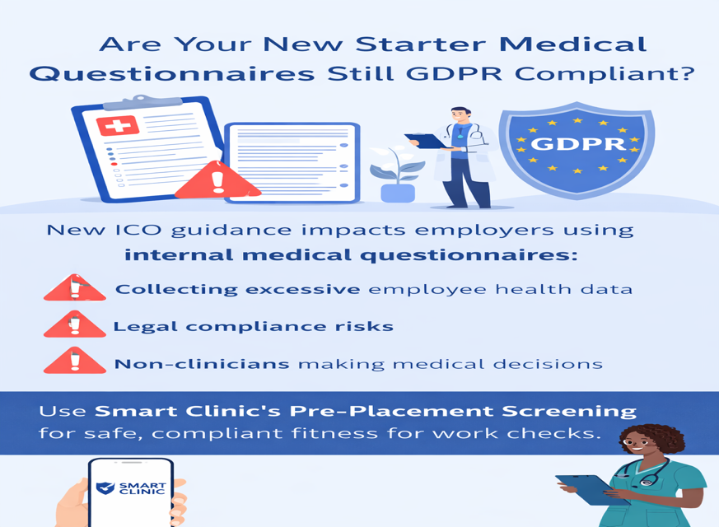 |  |  |  | The Role of Occupational Health Professionals  Rather than employers collecting and interpreting medical information themselves, the ICO advises that medical professionals should gather and assess health data.  Occupational health providers are qualified to:  - Design appropriate health questionnaires  - Interpret clinical information correctly  - Provide non-clinical, practical advice to employers  This approach protects employee privacy and ensures decisions about fitness for work are made responsibly.  The ICO specifically states: “It is good practice for health professionals to design health questionnaires. This also means the questionnaires should be interpreted by those who are qualified to draw meaningful conclusions from the information supplied by the worker.”  New Starter Health Questionnaires Can Be Risky  A Simple, Compliant Alternative  The good news: our service includes access to our Pre-Placement Screening Assessment, designed and reviewed by occupational health professionals.  With us you:  - Remain aligned with ICO and GDPR guidance  - Avoid storing sensitive medical data internally  - Receive clear, fit-for-purpose fitness for work advice  - Remove the burden of clinical decision-making from non-clinicians  Protect Your Business and Your Employees  Time to Scrap the Questionnaires  If you’re still using internal new starter health questionnaires, now is the time to stop.  Scrap the questionnaires and use our Pre-Placement Screening Service for all new starter fitness for work checks — a smarter, safer, and fully compliant solution.
 |  |  | Page 3

People for Business |  | Protected Characteristics |  |  |  |  |  | Business for People
This might sound like a complicated term, but it’s actually quite simple.
Protected characteristics are just the personal parts of who someone is—things like their age, race, gender, religion, disability, or sexual orientation. These are all things that make people who they are, and the law says people should not be treated badly because of them.
So, in simple terms, everyone has the right to be treated fairly and with respect, no matter who they are.
What are the 9 protected characteristics?
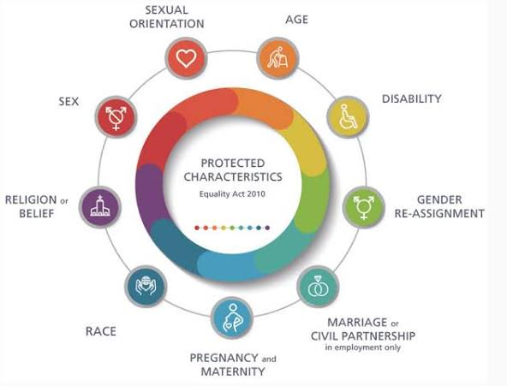
Now here’s something really important that people often don’t realise—you don’t actually have to have that characteristic yourself to be affected by it.
For example, if someone is making offensive jokes about a certain religion or group of people, even if no one in the room belongs to that group, it can still make others feel uncomfortable, awkward, or even upset.
Why? Because it creates a negative environment.
So ,this isn’t just about one person being targeted—it’s about the kind of workplace we’re creating for everyone.
Think about it like this: if people hear comments, jokes, or behaviour that feels disrespectful, they might start to feel uneasy. They might stop speaking up, avoid certain people, or feel like they don’t belong.
And over time, that can affect confidence, teamwork, and morale. People might not perform at their best, and the overall atmosphere can become negative.
That’s why this matters so much.
Workplaces should be places where people feel comfortable being themselves. Where differences are respected, not judged.
So what should you do in practice?
First, be aware of differences. Everyone comes from different backgrounds and experiences, so what seems normal to one person might not be to someone else.
Second, avoid making assumptions or jokes about people. Even if you don’t mean harm, it can still have an impact.
Third, if you see behaviour that doesn’t feel right, don’t ignore it. You can challenge it in a respectful way or report it if needed.
It’s about creating a culture where people look out for each other.
At the end of the day, this all comes down to one simple thing—treating people how you would want to be treated.
If we all do that, we create a workplace where people feel safe, valued, and respected—and that benefits everyone.”

 | We now offer a full Health & Safety support service with fully qualified Health & Safety Consultant partner.  Call us on 07375 097443 or e-mail enquiries@lbjconsultants.co.uk for more details. |  |  |  | LBJ Consultants  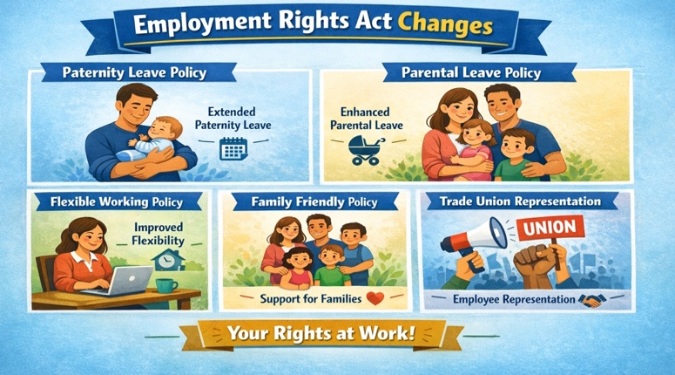  People for Business - Business for People
 |  |  |  | Page 4

